This controller has an action map with an error action also.

2. Now, create Testcontroller by Gii, but set the value of the base class field as app/components/BaseController:

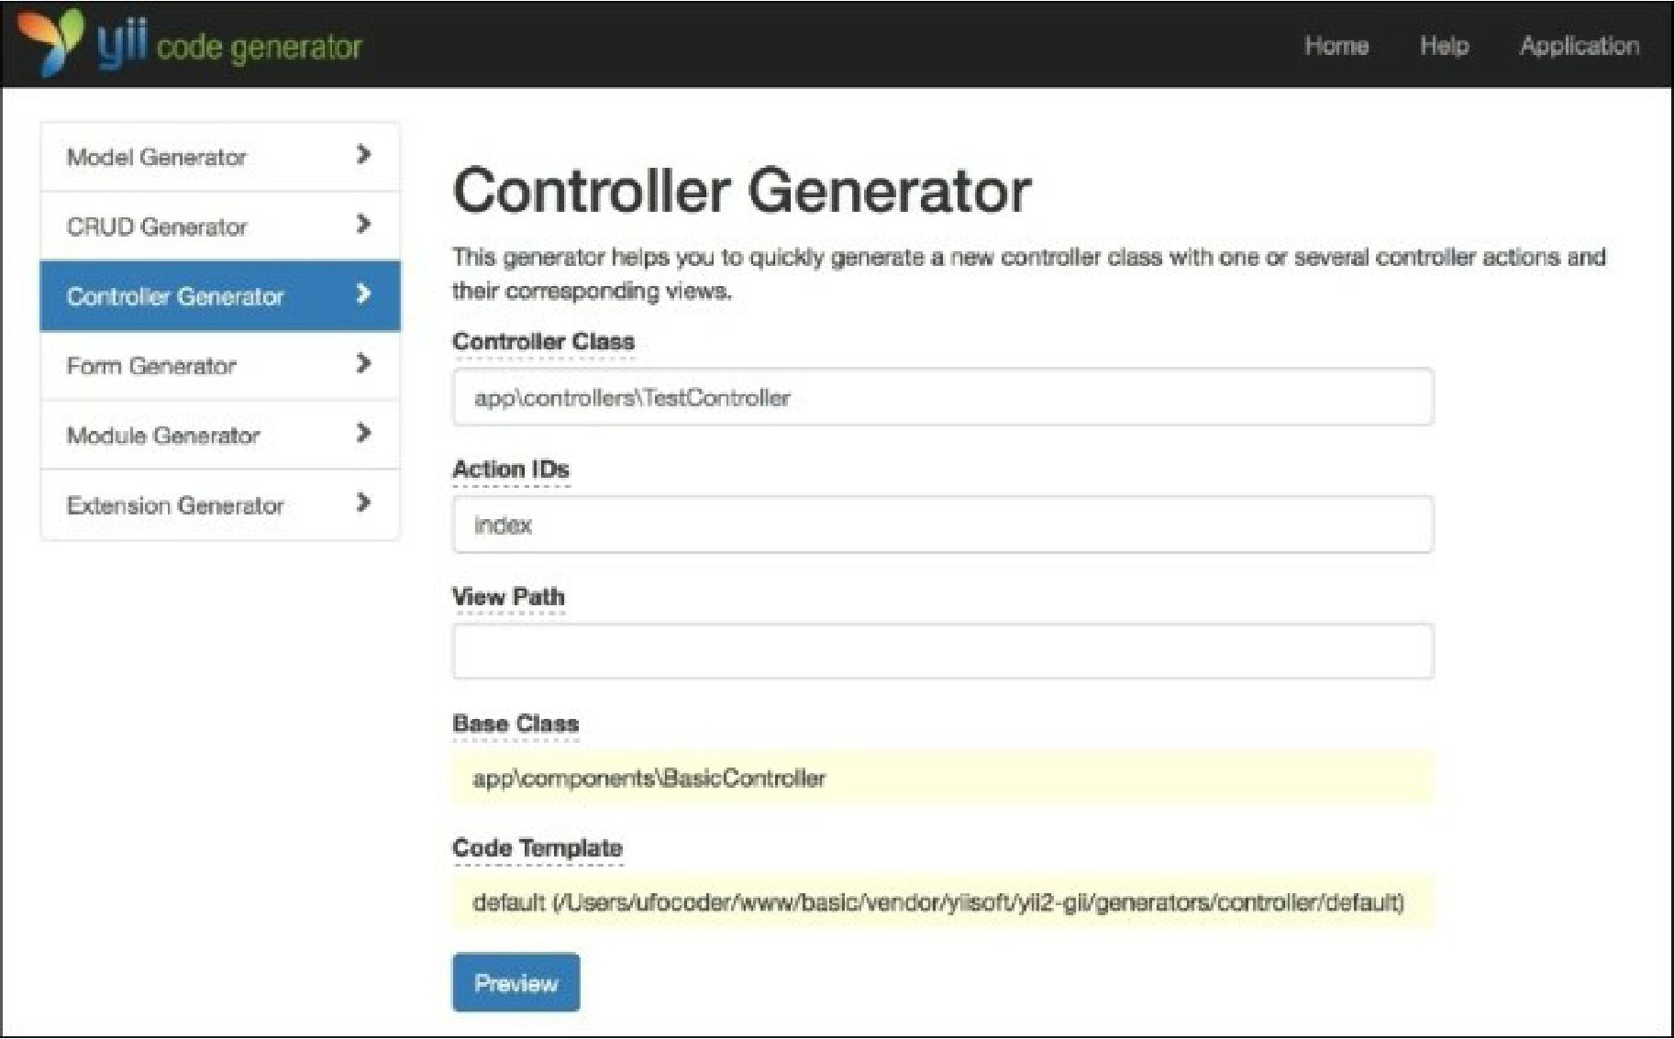

You will get something similar to the following:

<?php

namespace app\controllers;

class Testcontroller extends \app\components\BaseController {

public function actionIndex()

{

return $this->render('index');

}

}

3. Now, your TestController will be only accessible if the user is logged in, even though we have not declared it explicitly in the TestController class. You can check it by visiting [http://yii- book](http://yii-book) . app/index . php?r=test/index while logged out.

How it works...

The trick is nothing more than a basic class inheritance. If filters or access control rules are not found in TestController, then they will be called from SecureController.